Iot based Smart Pill Box

Architecture diagram or block diagram

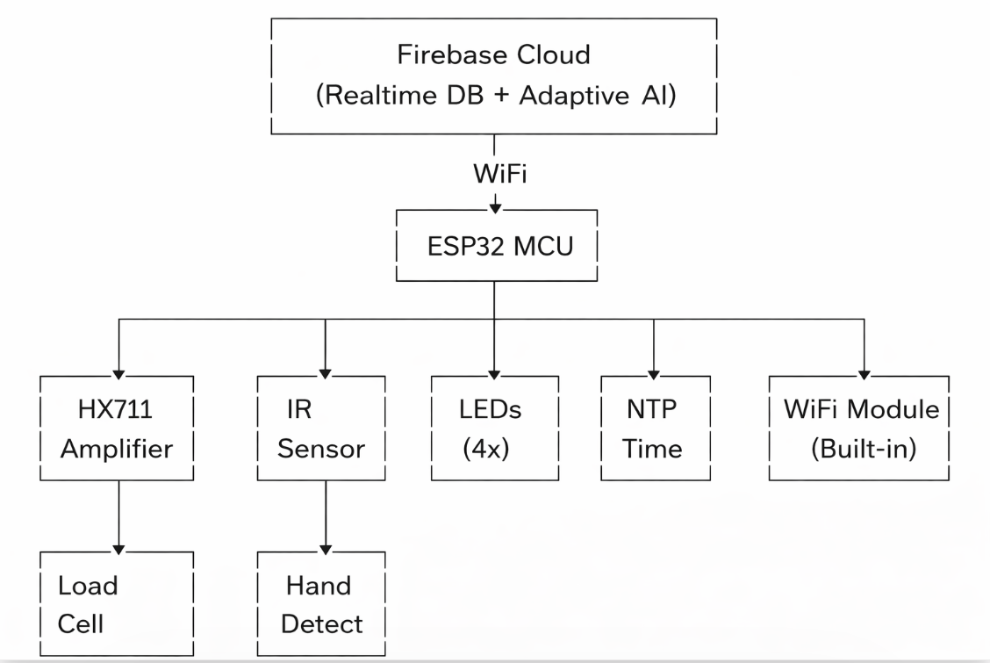

Explanation:
The ESP32 is the brain. It reads two sensors — a weight sensor and an IR sensor. Based on what it reads, it lights up LEDs to remind the patient. It also sends data to Firebase (cloud) through WiFi so the doctor or caretaker can check online.
- Load Cell + HX711 → checks if pill was taken by measuring weight drop
- IR Sensor → checks if hand was inserted into the box
- LEDs → blink to remind the user to take medicine
- WiFi → sends data to cloud
- Firebase → stores pill history online
- NTP Server → gives correct time so timestamps are accurate
- Web Dashboard → shows live pill status on phone/laptop

concrete diagram or circuit diagram

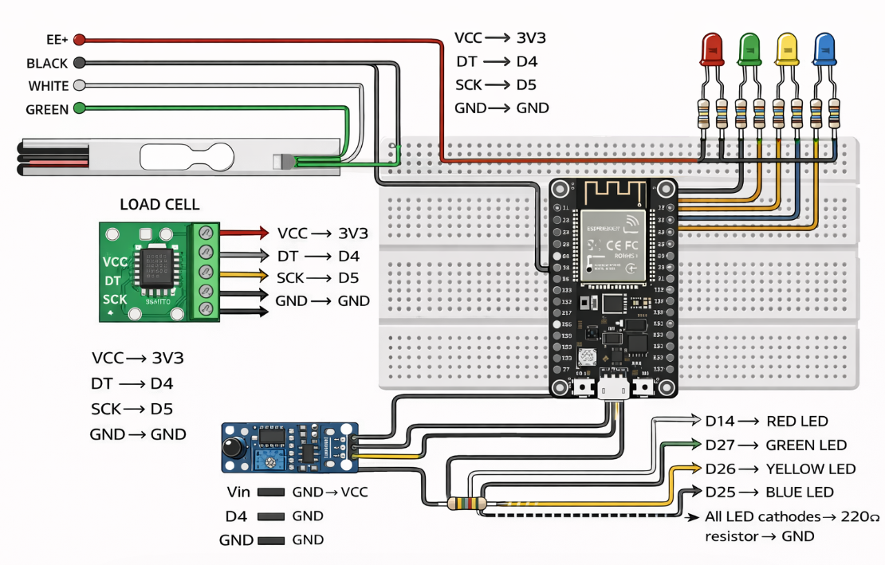

HX711 TO LOAD CELL
1. E+ connect with red wire
2. E- connect with black wire
3. A- connect with white wire 4.
A+ connect with green wire

esp32 to Hx711
1. 3v3 connect with vcc
2. D5 connect with SCK
3. D4 connect with DT
4. GND connect with GND

esp32 to IR sensor
1. Vin connect with Vcc
2. Gnd connect with Gnd
3. D33 connect with out

esp32 to LEDS
1. D14 connect to 1st LED anode
2. D27 connect to 2nd LED anode
3. D26 connect to 3rd LED anode
4. D25 connect to 4th LED anode
5. Gnd connect to 220 ohms resistor with series to all led cathode

Component list with cost
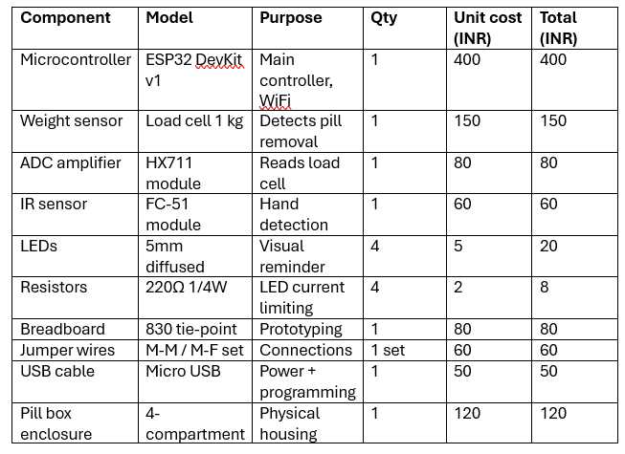

Tota cost: 1028 rupees.

Dataset

What data your system collects — pill taken/missed status, timestamp, weight at time of detection, round number, adjusted reminder time
Where it is stored — Firebase Realtime Database
Format — JSON key-value structure under /slots/MORNING, /slots/AFTERNOON, etc.
Size — grows by 1 record per slot per round, 4 records per round
How it is labelled — TAKEN or NOT TAKEN with metadata

